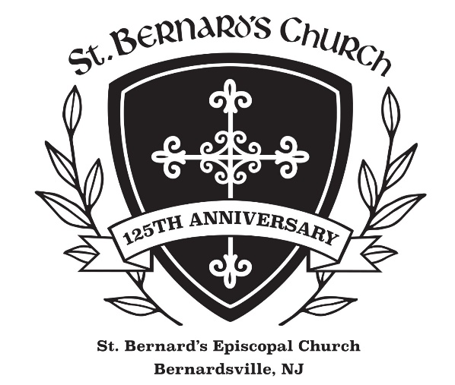

88 Claremont Road, Bernardsville, NJ 07924
The Day of Pentecost
May 28, 2023

10:00 a.m. Holy Eucharist

Welcome to St. Bernard’s Episcopal Church. Thank you for sharing in our worship today. We also welcome our Zoom worshipers. Restrooms are found in the Parish House next door. Please join us for refreshments in the Hall following the service.

PRELUDE
PROCESSIONAL HYMN 505 O Spirit of Life
1 O Spirit of Life, O Spirit of God,  in every need thou bringest aid;  thou comest forth from God’s great throne,  from God, the Father and the Son;  O Spirit of Life, O Spirit of God. | 2 O Spirit of Life, O Spirit of God,  increase our faith in our dear Lord;  unless thy grace the power should give,  none can believe in Christ and live;  O Spirit of Life, O Spirit of God.
3 O Spirit of Life, O Spirit of God,  make us to love thy sacred word;  the holy flame of love impart,  that charity may warm each heart;  O Spirit of Life, O Spirit of God. | 4 O Spirit of Life, O Spirit of God,  enlighten us by that same word;  teach us to know the Father’s love,  and his dear Son, who reigns above;  O Spirit of Life, O Spirit of God.
EASTER ACCLAMATION BCP p. 355
Celebrant Alleluia! Christ is risen!
People The Lord is risen indeed! Alleluia!
PENTECOST CALL TO WORSHIP Common Worship, Church of England
Celebrant Jesus Christ, whom we worship, is our crucified, risen and ascended Lord and we have walked with him through his journey of love. We have faced the agony of his suffering and death on a cross. We have rejoiced at his bursting free from the bonds of death. We have enjoyed his risen presence with us and his revelation of himself through the breaking of bread. We have seen his return to the throne before which every knee shall bow and every tongue confess that this Jesus is Lord. And now, with the followers of his own time, we await the coming of the promised Holy Spirit, his gift to his people, through whom we make Christ known to the world.
Deacon As we wait in silence,
People fill us with your Spirit.
Deacon As we listen to your word,
People fill us with your Spirit.
Deacon As we worship you in majesty,
People fill us with your Spirit.
Deacon As we long for your refreshing,
People fill us with your Spirit.
Deacon As we long for your renewing,
People fill us with your Spirit.
Deacon As we long for your equipping,
People fill us with your Spirit.
Deacon As we long for your empowering,
People fill us with your Spirit.
GLORIA S 280 Gloria in excelsis found in the blue hymnal
Glory to God in the highest, and peace to his people on earth. Lord God, heavenly King,
almighty God and Father, we worship you, we give you thanks, we praise you for your glory.
Lord Jesus Christ, only Son of the Father, Lord God, Lamb of God, you take away the sin of the world: have mercy on us; you are seated at the right hand of the Father: receive our prayer.
For you alone are the Holy One, you alone are the Lord, you alone are the Most High,
Jesus Christ, with the Holy Spirit, in the glory of God the Father. Amen.
THE COLLECT OF THE DAY Revised Common Lectionary Prayers
Celebrant The Lord be with you. People And also with you.
Let us pray. Holy God, you spoke the world into being. Pour your Spirit to the ends of the earth, that your children may return from exile as citizens of your commonwealth, and our divisions may be healed by your word of love and righteousness. Amen.
COLLECT FOR MEMORIAL DAY (A Thanksgiving for Heroic Service) BCP p. 839

Deacon O Judge of the nations, we remember before you with grateful hearts the men and women of our country who in the day of decision ventured much for the liberties we now enjoy. Grant that we may not rest until all the people of this land share the benefits of true freedom and gladly accept its disciplines. This we ask in the Name of Jesus Christ our Lord. Amen.

FIRST READING: Acts 2:1-21 read by Valerie McEnteer

Lector A Reading from the Acts of the Apostles.
When the day of Pentecost had come, the disciples were all together in one place. And suddenly from heaven there came a sound like the rush of a violent wind, and it filled the entire house where they were sitting. Divided tongues, as of fire, appeared among them, and a tongue rested on each of them. All of them were filled with the Holy Spirit and began to speak in other languages, as the Spirit gave them ability. Now there were devout Jews from every nation under heaven living in Jerusalem. And at this sound the crowd gathered and was bewildered, because each one heard them speaking in the native language of each. Amazed and astonished, they asked, “Are not all these who are speaking Galileans? And how is it that we hear, each of us, in our own native language? Parthians, Medes, Elamites, and residents of Mesopotamia, Judea and Cappadocia, Pontus and Asia, Phrygia and Pamphylia, Egypt and the parts of Libya belonging to Cyrene, and visitors from Rome, both Jews and proselytes, Cretans and Arabs—in our own languages we hear them speaking about God's deeds of power.” All were amazed and perplexed, saying to one another, “What does this mean?” But others sneered and said, “They are filled with new wine.”
But Peter, standing with the eleven, raised his voice and addressed them, “Men of Judea and all who live in Jerusalem, let this be known to you, and listen to what I say. Indeed, these are not drunk, as you suppose, for it is only nine o’clock in the morning. No, this is what was spoken through the prophet Joel:
‘In the last days it will be, God declares, that I will pour out my Spirit upon all flesh, and your sons and your daughters shall prophesy, and your young men shall see visions, and your old men shall dream dreams. Also, upon the enslaved, both men and women, in those days I will pour out my Spirit; and they shall prophesy. And I will show portents in the heaven above and signs on the earth below, blood, and fire, and smoky mist. The sun shall be turned to darkness and the moon to blood, before the coming of the Lord’s great and glorious day. Then everyone who calls on the name of the Lord shall be saved.’ “

Lector The Word of the Lord. People Thanks be to God.

PSALM 104:25-35, 37 sung by the choir with congregational antiphon Guimont, BCP pp. 736-737

Antiphon
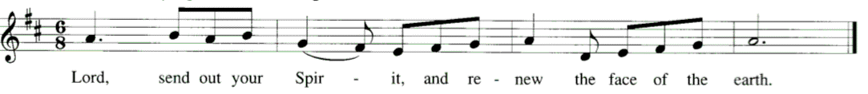

Bless the Lord, O my soul! O Lord, my God, you are great indeed!
You are clothed with majesty and glory, robed in light as with a cloak. Antiphon
How manifold are your works, O Lord! In wisdom you have wrought them all
The earth is full of your creatures; Bless the Lord, O my soul! Alleluia. Antiphon
Creatures all look to you to give them food in due time.
When you give it to them, they gather it; when you open your hand, they are filled with good things. Antiphon

If you take away their breath they perish and return to their dust.
When you send forth your spirit, they are created, and you renew the face of the earth. Antiphon

SECOND READING: 1 Corinthians 12:3b-13 read by Chris Thomas

Lector A Reading from the First Letter of Paul to the Corinthians.
No one can say “Jesus is Lord” except by the Holy Spirit. Now there are varieties of gifts, but the same Spirit; and there are varieties of services, but the same Lord; and there are varieties of activities, but it is the same God who activates all of them in everyone. To each is given the manifestation of the Spirit for the common good. To one is given through the Spirit the utterance of wisdom, and to another the utterance of knowledge according to the same Spirit, to another faith by the same Spirit, to another gifts of healing by the one Spirit, to another the working of miracles, to another prophecy, to another the discernment of spirits, to another various kinds of tongues, to another the interpretation of tongues. All these are activated by one and the same Spirit, who allots to each one individually just as the Spirit chooses. For just as the body is one and has many members, and all the members of the body, though many, are one body, so it is with Christ. For in the one Spirit we were all baptized into one body—Jews or Greeks, slaves or free—and we were all made to drink of one Spirit.

Lector The Word of the Lord. People Thanks be to God.

POEM: Pentecost by Malcolm Guite (b. 1957) read by Julia Somers
Today we feel the wind beneath our wings
Today the hidden fountain flows and plays
Today the church draws breath at last and sings
As every flame becomes a Tongue of praise.
This is the feast of fire, air, and water
Poured out and breathed and kindled into earth.
The earth herself awakens to her maker
And is translated out of death to birth.
The right words come today in their right order
And every word spells freedom and release
Today the gospel crosses every border
All tongues are loosened by the Prince of Peace
Today the lost are found in His translation.
Whose mother-tongue is Love, in every nation.

GRADUAL HYMN 508 Breathe on me, Breath of God
1 Breathe on me, Breath of God,  fill me with life anew,  that I may love what thou dost love,  and do what thou wouldst do. | 2 Breathe on me, Breath of God,  until my heart is pure,  until with thee I will one will,  to do or to endure.
3 Breathe on me, Breath of God,  till I am wholly thine,  till all this earthly part of me  glows with thy fire divine. | 4 Breathe on me, Breath of God,  so shall I never die;  but live with thee the perfect life  of thine eternity.

THE HOLY GOSPEL: John 7:37-39
Deacon The Holy Gospel of our Lord Jesus Christ according to John.
People Glory to you, Lord Christ.
We encourage you to listen to the Gospel. To read along, the Gospel can be found in the pew Bible on p. 930.
Deacon The Gospel of the Lord.
People Praise to you, Lord Christ.

THE SERMON The Rev. Beth Rauen Sciaino
RENEWAL OF THE BAPTISMAL COVENANT BCP p. 292
Celebrant On this Day of Pentecost, as we celebrate the birth of the Church by God’s gift of the Holy Spirit, let us renew the promises of Holy Baptism, by which we once renounced evil in all its forms and promised to serve God faithfully through the Church which is Christ’s Body.
Celebrant Do you reaffirm your renunciation of evil and renew your commitment to Jesus Christ?
People I do.
Celebrant Do you believe in God the Father?
People I believe in God, the Father almighty, creator of heaven and earth.
Celebrant Do you believe in Jesus Christ, the Son of God?
People I believe in Jesus Christ, his only Son, our Lord. He was conceived by the power of the Holy Spirit and born of the Virgin Mary. He suffered under Pontius Pilate, was crucified, died, and was buried. He descended to the dead. On the third day he rose again. He ascended into heaven, and is seated at the right hand of the Father. He will come again to judge the living and the dead.
Celebrant Do you believe in God the Holy Spirit?
People I believe in the Holy Spirit, the holy catholic Church, the communion of saints, the forgiveness of sins, the resurrection of the body, and the life everlasting.
Deacon Will you continue in the apostles’ teaching and fellowship, in the breaking of bread, and in the prayers?
People I will, with God’s help.
Deacon Will you persevere in resisting evil, and, whenever you fall into sin, repent and return to the Lord?
People I will, with God’s help.
Deacon Will you proclaim by word and example the Good News of God in Christ?
People I will, with God’s help.
Deacon Will you seek and serve Christ in all persons, loving your neighbor as yourself?
People I will, with God’s help.
Deacon Will you strive for justice and peace among all people, and respect the dignity of every human being?
People I will, with God’s help.
Celebrant May Almighty God, the Father of our Lord Jesus Christ, who has given us a new birth by water and the Holy Spirit, and bestowed upon us the forgiveness of sins, keep us in eternal life by his grace, in Christ Jesus our Lord. Amen.
THE PRAYERS OF THE PEOPLE led by Valerie McEntee Form II, BCP p. 385
In the course of the silence after each bidding, the People offer their own prayers, either silently or aloud.
Leader I ask your prayers for God’s people throughout the world; for our Presiding Bishop
Michael, diocesan Bishop Chip, and Bishop-elect Sally; for this gathering; and for all
ministers and people. Pray for the Church. Silence
Leader I ask your prayers for peace; for goodwill among nations; and for the well-being of
all people. Pray for justice and peace. Silence
Leader I ask your prayers for people who are poor, sick, hungry, oppressed, and in prison.
Pray for those in any need or trouble. Silence
Leader I ask your prayers for all who seek God, or a deeper knowledge of the Holy. Pray
that they may find and be found by God. Silence
Leader I ask your prayers for the departed. Pray for those who have died. Silence
Leader I ask your prayers for those on our Prayer List: (read names). Silence
Leader Praise God for those in every generation in whom Christ has been honored. Pray that
we may have grace to glorify Christ in our own day. Silence
The Deacon adds a concluding Collect.
PRAYER a version of the Lord’s Prayer by Jim Cotter, A New Zealand Prayer Book p. 181
Eternal Spirit, / Earth-maker, Pain-bearer, Life-giver, / Source of all that is and that shall be,
Father and Mother of us all, / Loving God, in whom is heaven:
The hallowing of your name echo through the universe! / The way of your justice be followed by the peoples of the world! / Your heavenly will be done by all created beings! / Your commonwealth of peace and freedom / sustain our hope and come on earth.
With the bread we need for today, feed us. / In the hurts we absorb from one another, forgive us. / In times of temptation and test, strengthen us. / From trials too great to endure, spare us.
From the grip of all that is evil, free us.
For you reign in the glory of the power that is love, now and for ever. Amen.

THE PEACE
Celebrant The peace of the Lord be always with you.
People And also with you.
WELCOME, Announcements & CeleBRATIONS

THE HOLY COMMUNION
During the Offertory Anthem an offering is collected for God’s mission and ministry. Thank you for your generosity.

OFFERTORY ANTHEM O Hail this Joyful Day by Christopher Tye
O hail this joyful day’s return, hail to the ascended Lord,
Who on this day, upon his church, his Spirit has outpoured.
And like as cloven tongues of flame, that earth might hear the call,
On Pentecost the Spirit came that love may burn in all.
Unfailing comfort, heav'nly guide, with rushing wind and fire,
O grant your blessings from above, Jesus, our heart’s desire.
As with your promise, we believe these gifts you have in store,
Make us now ready to receive that joy forever more.

PRESENTATION OF THE GIFTS All stand and sing. Lasst uns erfreuen
Praise God from whom all blessings flow; praise him, all creatures here below: Alleluia, alleluia! Praise him above ye heavenly host; praise Father, Son, and Holy Ghost:
O praise him, O praise him, alleluia (repeated).
THE GREAT THANKSGIVING Eucharistic Prayers, Pentecost, pp. 182-3
Celebrant The Lord be with you.
People And also with you.
Celebrant Lift up your hearts.
People We lift them to the Lord.
Celebrant Let us give thanks to the Lord our God.
People It is right to give God thanks and praise.
Celebrant God of surprises, your Spirit brooded over the waters at creation and lived among your chosen people in wilderness, exile, and promised land. Your Spirit filled Mary’s womb at the moment of Jesus’ conception and came upon him like a dove at his baptism. When Christ died on the cross your power raised him from the tomb on the third day, and that same evening he breathed your forgiving grace on those who had deserted him. On the day of Pentecost you sent your Spirit upon the fearful disciples, filling them with fire, with power, with wonder and joy, and making them your church.
And so we gladly thank you, with angels and archangels and all the company of heaven, singing the hymn of your unending praise.
SANCTUS AND BENEDICTUS S 130 sung by all Schubert
Holy, holy, holy Lord, God of power and might,
Holy, holy, holy Lord, God of power and might,
heaven and earth are full, full of your glory.
Hosanna in the highest, Hosanna in the highest.
Blessed is he who comes in the name of the Lord.
Hosanna in the highest, Hosanna in the highest.

Celebrant God of comfort and strength, we look to your Holy Spirit to be with us in sorrow and in contentment, in crisis and in abiding stillness. Come among us now through the power of your Spirit, that we may be transformed into your image, and that these gifts of bread and wine may become for us the body and blood of your Son Jesus Christ; who, at supper with his disciples, took bread, gave you thanks, broke the bread, and gave it to them, saying, “Take, eat: this is my body which is given for you; do this in remembrance of me.” After supper he took the cup. Again he gave you thanks, and gave it to his disciples, saying, “Drink this, all of you: this is my blood of the new covenant, which is shed for you and for all for the forgiveness of sins. Do this, as often as you drink it, in remembrance of me.” Great is the mystery of faith:
Celebrant Great is the mystery of faith.
People Christ has died; Christ is risen; Christ will come again.
Celebrant God of dreams and prophecy, send down upon us your gifts of wisdom, knowledge, and faith; of healing, discernment, and interpretation, that your church may be built up in the likeness of your Son. Let anyone who is hungry find in you the bread of life, and anyone who is thirsty find in you rivers of living water. Speak your word to all who are alone and in fear or despair, and let each one of your children hear your voice in their own language, whether that language be art or science, work or play. Sanctify your groaning creation, that your universe may breathe your breath and be filled with your life anew, that we may love what you love, and do what you would do, Father, Son, and Holy Spirit, ever one God. AMEN.
THE LORD’S PRAYER BCP p. 364
Celebrant And now, as our Savior Christ has taught us, we are bold to say,
Our Father, who art in heaven, hallowed be thy Name, thy kingdom come, thy will be done, on earth as it is in heaven. Give us this day our daily bread. And forgive us our trespasses, as we forgive those who trespass against us. And lead us not into temptation, but deliver us from evil. For thine is the kingdom, and the power, and the glory, for ever and ever. Amen.
THE BREAKING OF THE BREAD The Celebrant breaks the consecrated Bread. Silence is kept.
FRACTION ANTHEM sung by all Wonder, Love and Praise 791, stanza 5
Alleluia, alleluia, alleluia. Alleluia, alleluia, alleluia.
INVITATION TO COMMUNION
Celebrant The Gifts of God for the People of God. Come and meet the Risen Christ.
You are welcome to say A Prayer for Spiritual Communion found below during Communion.
A PRAYER FOR SPIRITUAL COMMUNION (Diocese of Oxford, England)
Lord, you stand at the door of my heart and knock.
You wait for me and only I can let you in.
I believe and trust in you and ask you now to fill me with your presence.
Feed me with your Body and unite me in your Blood,
that I may be your blessing to a world in need. Amen.
COMMUNION ANTHEM Come, Holy Ghost by Orlando Gibbons
POST COMMUNION PRAYER BCP p. 365
Celebrant Let us stand and pray.
Eternal God, heavenly Father, / you have graciously accepted us as living members
of your Son our Savior Jesus Christ, / and you have fed us with spiritual food
in the Sacrament of his Body and Blood.
Send us now into the world in peace,
and grant us strength and courage / to love and serve you
with gladness and singleness of heart; / through Christ our Lord. Amen.
THE BLESSING
May the Spirit, who set the Church on fire upon the Day of Pentecost, bring the world alive with the love of the risen Christ; and the blessing of God Almighty, the Father, the Son, and the Holy Spirit, be among you and remain with you always. Amen.

RECESSIONAL HYMN 501 Holy Spirit, by whose breath
1 O Holy Spirit, by whose breath  life rises vibrant out of death;  come to create, renew, inspire;  come, kindle in our hearts your fire. | 2 You are the seeker’s sure resource,  of burning love the living source,  protector in the midst of strife,  the giver and the Lord of life.
3 In you God’s energy is shown,  to us your varied gifts make known.  Teach us to speak, teach us to hear;  yours is the tongue and yours the ear. | 4 Flood our dull senses with your light;  in mutual love our hearts unite.  Your power the whole creation fills;  confirm our weak, uncertain wills.
5 From inner strife grant us release;  turn nations to the ways of peace.  To fuller life your people bring  that as one body we may sing: | 6 Praise to the Father, Christ, his Word,  and to the Spirit: God the Lord,  to whom all honor, glory be  both now and for eternity.
THE DISMISSAL
Deacon Filled with the Spirit’s power, go in the light and peace of Christ. Alleluia, alleluia!
People Thanks be to God. Alleluia, alleluia!

POSTLUDE
       

ASSISTING TODAY AT OUR SERVICE  Celebrant & Preacher The Rev. Beth Rauen Sciaino  Deacon The Rev. Karen B. Lewis  Director of Music Dr. Martin Sedek  St. Bernard’s Choir  Lectors Valerie McEntee, Chris Thomas, Julia Somers  Usher Pam Hull | St. Bernard’s Wardens and Vestry  Christopher Thomas, Paul Edwards, Wardens  Michael Myers, Treasurer; Linda Engleby, Clerk  Zach Conway, Linda Engleby, Anne Fritts,  Beth Gustafson, Taylor Hwong, Mary Kempen,  Meg McKee, Jennifer Moss,  Michael Myers, Sue Smith

DONATIONS VIA PAYPAL
Donations to St. Bernard’s Episcopal Church
can be made via PayPal.
To make a donation via PayPal,
please use this QR Code.
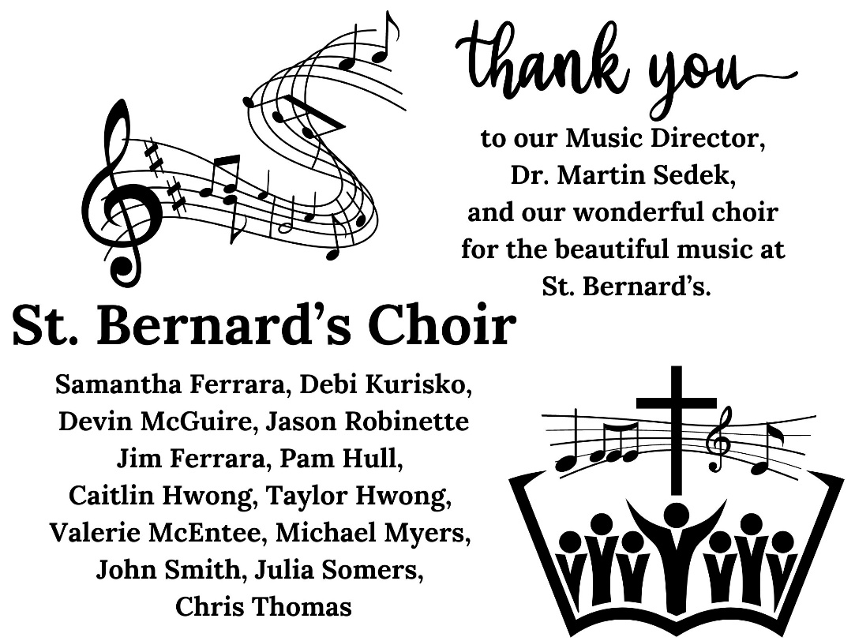

ANNOUNCEMENTS May 28, 2023

WORSHIP & COMMUNITY

Honoring our Graduates on Sun. June 18. Tell us whose Graduating!
If someone in your family has recently graduated or is about to graduate from Middle School, High School or College (undergraduate or post-graduate degrees) then please let us know, so that we can honor them in our June 18 service! Email Alison, our Parish Administrator, admin@stbernardsnj.org, the following information: 1. Name of Graduate; 2. Relationship to you; 3. School they've graduated or will be graduating from; 4.Where they're going next, i.e. school or college etc.; 5. If graduated from college, their degree; 6. You are also welcome to include a photo of your graduate!

St. Bernard’s Church welcomes volunteers
St. Bernard’s welcomes volunteers to help with Sunday 10 am worship for Altar guild (setting and cleaning up the sacred vessels and elements), Chalicist (serving as a Lay Eucharistic Minister during Holy Communion), Acolyte (carrying torches and assisting, elementary-high school), Lector (reading), or Usher. If interested please speak with Pastor Beth or reach out to the Parish Administrator, Alison Davidson, admin@StBernardsNJ.org or 908-766-0602. Training is available and all are welcome.
Evening Prayer - next service, Wed., May 31, 5:30 pm on Zoom
Evening Prayer is held every other week until June 28, breaking for the summer. Resources are available on slides during Zoom and on our website: stbernardsnj.org/worship-services-via-zoom .
JOY! Service: 3rd Sunday of the month at 9 am: June 18. This 20-minute informal service is designed for families with children. All are welcome!
St. Bernard’s Prayer List
To add or to remove someone from our prayer list, please contact our Parish Administrator, admin@stbernardsnj.org.

Pastoral Visit
Please contact Pastor Beth at priest@stbernardsnj.org or 908-766-0602 to schedule a visit or conversation for yourself or a relative or friend.

Offerings at Cross Roads Camp and Retreat Center, Port Murray, NJ:
Open House: on Sat., June 10. To register or learn more: https://bit.ly/41ibJNg . There are camp offerings for Youth camp or family camp: sign up at www.CrossRoadsRetreat.com. Bishops’ Cup Golf Outing, Mon., Jun 12 to support Cross Roads by participating: https://www.crossroadsretreat.com/golf_outing/
Looking Ahead: Worship in July at Moorlands Farm, July 9, 9am
St. Mark’s, St. John on the Mountain, St. Luke’s, and St. Bernard’s will be returning to Moorland Farm for an outdoor 9 am service (under a tent) on Sunday, July 9. Check back for more details.
Anglican Rosaries and Books for Sale
Courtesy of St. Mark’s Episcopal Church, Basking Ridge, we have some Anglican rosaries and books for praying with the rosary available for purchase in the church Narthex. This includes a version for children. An Anglican rosary is a tool that can help one pray with the Scriptures. Proceeds go to St. Mark’s.
Vacation Bible School, June 19-23, at Ross Farm
The VBS of St Bernard’s, St John on the Mountain, and St Mark’s will be June 19-23, 9 am to 12 pm.
There is no “fee” for this camp, but a suggested donation of $50 per child will help in defraying the cost of materials. Checks can be made payable to “St John on the Mountain” with “VBS” in the memo line. All children, ages 3 through rising 4th graders are welcome. Older children invited as helpers and camp counselors. Go to this link to sign up your child(ren). https://stmarksbr.org/vbs/
AFFILIATION PROCESS
Thank you to those who attended the recent affiliation meeting that gathered parishioners from St. Bernard’s and St. John on the Mountain. The meeting was led by Canon Joanne Izzo and Canon Phyllis Jones of the Diocese of NJ. A vote was taken at the conclusion of the meeting in which almost 85% of the people present voted to move to the next step of the affiliation process. This next step sets up a Steering Committee made up of four parishioners from each parish, half of which are current Vestry members. The first task of the Steering Committee is to draft a Memorandum of Understanding (MOU) that will be shared with both parishes and provide some specificity. Affiliation for a three-year period begins when a MOU is ratified by both Vestries and both parishes. The MOU is a living document and can be adjusted as needed during an affiliation. The Steering Committee continues to serve as a bridge between the parishes and an ongoing site of evaluation during an affiliation. The Wardens, Vestry, and Beth are available for conversation.

OUTREACH
Food Bank Drive for Food Bank Network of Somerset County & Feeding America BackPack Program
Non-perishable food donations welcomed. Drop off in the recycling bin outside of the church. Please help to spread the word. Thank you!

Curbing Hunger-Summer Food Drive
If you live in Somerset County you will have received an orange bag on one of your recycling cans. Please fill the bag with nonperishables and set it out with your recycling, it will be picked up and taken to the Food Bank. Thank you for your generosity!
Shoe Collection for Shiloh Baptist Church
Shiloh Baptist Church in Newark is collecting gently worn, used and new shoes to sell as a fundraiser a fundraiser to help rebuild the church building badly damaged during a snowstorm.

125TH ANNIVERSARY UPCOMING CELEBRATION EVENTS

SEPTEMBER: HISTORICAL TALK setting St. Bernard’s
in context of Bernardsville’s history.

OCTOBER: CHOIR CONCERT - Sacred Music through the Ages
Due to scheduling conflicts the choir concert has been rescheduled to take place in October.
SERVICE OF THANKSGIVING: Sunday, Nov. 19, 2 pm
for those who contribute to the community (both professionals and volunteers).
Masterworks Chorus will sing during this service.

MUSIC IN THE SOMERSET HILLS

Upcoming combined Somerset Hills & Rise Up Choruses sing “Annelies”, June 10 & 11
The Somerset Hills Chorus and Rise Up Chorus join together for a performance of James Whitbourn’s oratorio “Annelies,” based on The Diary of Anne Frank. June 10 perf. in Plainfield, June 11 perf. in Morristown. Go to www.musicsh.org/events-and-concert-info for more info and to buy tickets. St. Bernard’s Choir member Valerie McEntee, and our parish administrator, Alison Davidson, are singing with the Somerset Hills Chorus.

Summer Voices – June 26 – 29
Location: St. Bernard’s Episcopal Church; Tuition: $200. Summer Voices is Music in the Somerset Hills' popular annual program for young singers. Rising 2nd-12th graders are welcome to join in 4 days of group activities, individual singing, and musicianship building sessions with our amazing faculty of music teaching professionals. Register: MusicSH.org/childrens-vocal-camp-summer-voices

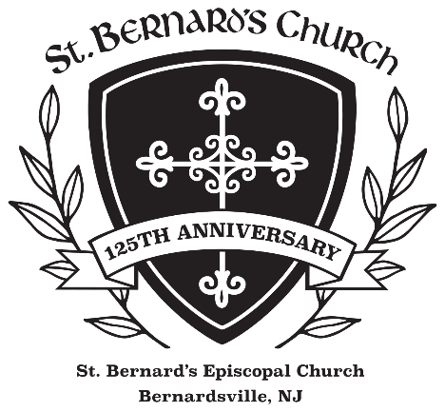

ST. BERNARD’S EPISCOPAL CHURCH
The Rev. Beth Rauen Sciaino, Rector
The Rev. Karen Burke Lewis, Deacon
88 Claremont Road, Bernardsville, NJ 07924
908-766-0602 www.StBernardsNJ.org

